(Approx. 470 words)

Very Large Array (VLA)
Author: George Harding, Treasurer, Tucson Computer Society, AZ
July 2019
www.aztcs.org
actuary110 (at) yahoo.com

The VLA is a physical structure about 50 mile west of Socorro, New Mexico. It consists of 27 large disk radio telescopes in a “Y” arrangement, a Control Center and various auxiliary structures. The purpose is to capture and analyze radio waves being emitted from space to create meaningful pictures and data about outer space objects.

It was originally created in 1980 and has been significantly improved since then. It is used by astronomers and others as needed in their respective occupations.

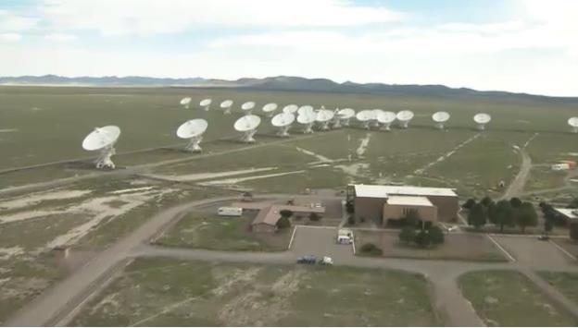

Each disk is massive, weighing 220 tons and is 82 feet in diameter and 94 feet high. It can rotate and tilt so as to aim in any given direction. Any disk can be moved along special railroad tracks. Since each disk presents such a large surface, they are subject to damage in high winds. In this event, the disk is parked pointing upward to present the least surface for the wind.
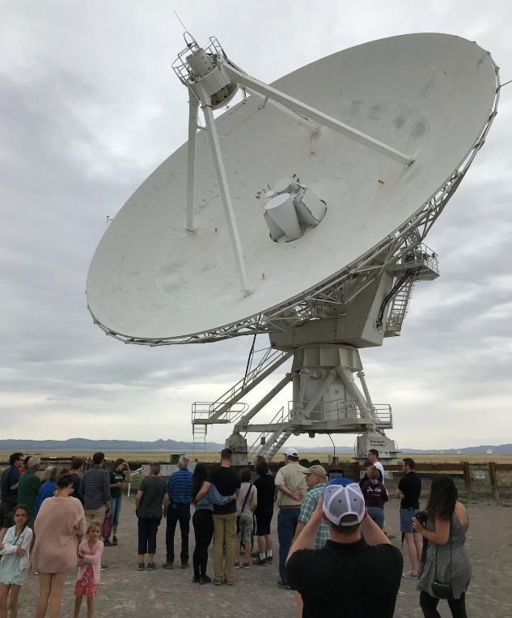

Each leg of the “y” formation contains nine disks, which can be rearranged in several ways. The configuration changes periodically from fully spread out along the “Y” to fully compressed and to two intermediate designs. The effect is to widen the aperture of the telescopes or to narrow them.

The signals from each disk are transferred by fiber optic cables to a system which translates the analog data to digital. The process is quite complicated but is performed by a supercomputer called the correlator.

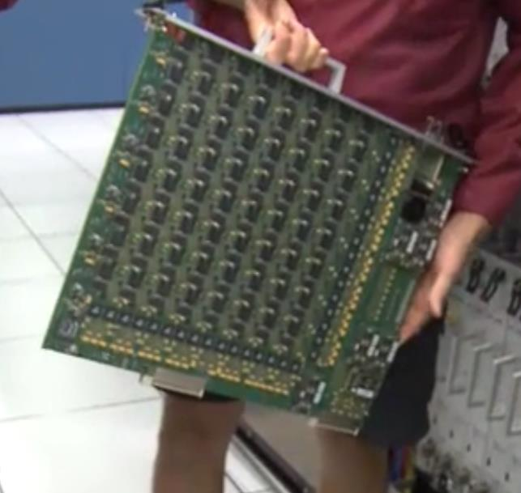
Each of the boards comprising the correlator contains some 180 ICs each with from 250 to 600 pins. VLA personnel state that it is five times faster than the fastest general- purpose computer in the world!

Anyone can access the data produced, for whatever purpose desired. The VLA can be requested for a particular job needed by an astronomer by submitting a proposal. If approved, the proposal is translated into a script for controlling the array for a specific period of time. After completion, the results are given to the requestor and after some months made available to the general public.

The facility is open to the public and a visitor center is available. Tours are provided from time to time.

The site of the VLA is the plains of San Augustin, selected to be as far away from other electronic emanations as possible. Cell phones, for example, emit a radio signal several hundred times louder than the faint signals from outer space. Visitors are asked to keep their phones in airplane mode to mask these signals. In addition, the plains are surrounded by mountains which help to shield the array from man-made radio noise.

For more information see
https://public.nrao.edu/telescopes/vla/

The Very Large Array is owned and operated by the National Radio Astronomy Observatory.

